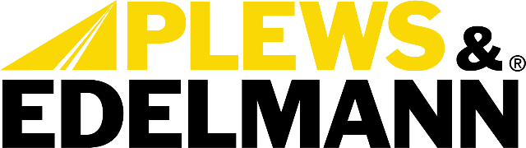

For Immediate Release:

Plews & Edelmann Launches Industry's First Application-Specific Power Steering System Bundles

• Revolutionary program eliminates guesswork with intelligent cataloging of
complete power steering repairs
• Over 3,000 bundles covering 1964-2022 vehicles available immediately through
existing distribution
(Dixon, IL - November 4, 2025) — Plews & Edelmann®, a pioneer in automotive power steering technology, has launched the industry's first application-specific power steering system bundles, fundamentally changing how complete power steering repairs are ordered and executed in the automotive aftermarket. Available immediately at AAPEX 2025, the comprehensive program covers over 3,000 vehicle applications spanning nearly six decades.
Each bundle delivers every component required for a complete power steering system repair: pump, rack and pinion assembly or gear box, power steering cooler (when applicable), pressure hoses, return hoses, universal filter, and two bottles of synthetic power steering fluid. The program leverages proprietary Edelmann Analytics® technology to ensure precise fitment across thousands of vehicle configurations.
"For years, we've championed complete power steering repairs yet incomplete repairs persisted." said Anthony Holguin, Director of Category Management at Plews & Edelmann. "The barrier wasn't knowledge—it was execution friction. Looking up components across multiple catalogs and ordering parts separately created systemic challenges that led to incomplete repairs. These bundles eliminate those barriers entirely."
The technical complexity of power steering bundling has prevented previous attempts at standardization. Vehicle variations by engine type, trim level, and auxiliary systems create cascading differences in components—from hose routing and bend radius to fitting angles and mounting brackets. A single model year can require dozens of unique configurations.

"Different engines mean different hoses or hard parts, but the complexity multiplies from there," explained Holguin. "One version has a cooler, another doesn't. Hose routing changes. Return fittings differ. These differences can be subtle—a tube bend, a fitting angle—but miss one detail and the part doesn't fit."
The bundle system addresses both incomplete repairs and the planning complexity that has historically plagued power steering service. Each bundle carries its own searchable part number representing the complete system for that exact vehicle configuration, with all components pre-selected by default. This approach shifts friction from component selection to optional deselection, while leveraging existing distributor inventory without requiring additional shelf space.
"Complete system repair stops being the exception and starts becoming standard practice," said Tony Edwards, VP of Sales at Plews & Edelmann. "Distributors can offer complete system solutions without inventory duplication. Technicians execute comprehensive repairs without catalog diving. Customers get repairs that last."
The program builds on the Plews & Edelmann Total Solution® philosophy, which has consistently demonstrated that warranty returns occur when technicians replace individual components while contaminated fluid or degraded hoses remain. By presenting complete system solutions as intelligent defaults, the bundles reduce the circumstances that lead to incomplete repairs and subsequent comebacks.
"When only the rack gets replaced, old hoses with degraded rubber remain, fresh fluid mixes with contaminated fluid, and six months later something fails," noted Holguin. "The customer returns convinced the new rack is defective. Complete system replacement eliminates these cascading failures. Bundles present the complete solution upfront."
The capability represents a competitive advantage unique to Plews & Edelmann, as no other manufacturer possesses both the comprehensive product portfolio spanning all power steering components and the decades of cataloging expertise required to map connections accurately across thousands of applications.
AAPEX attendees can learn more about application-specific power steering bundles at the Plews & Edelmann booth A3629, November 4-6 in Las Vegas.
For more information about Plews & Edelmann and its products, visit www.plews-edelmann.com or call 1-800-770-4639.

About Plews & Edelmann
Plews & Edelmann® is a leading manufacturer and marketer of Edelmann® power steering hoses, electric power steering belt replacement kits, couplings and tools, power steering seal and rebuild kits, turbocharger oil lines, Edelmann Elite® high performance power steering hoses, all new manufactured power steering rack and pinion assemblies, pumps, gear boxes, power steering coolers, premium universal power steering filter and fluid.

Media Contact:
Sharon Clark
Marketing Coordinator
Plews & Edelmann
1550 Franklin Grove Road
Dixon, Illinois 61021
Phone: 815-220-5444
Email: sclark@plews.com
www.plews-edelmann.com

Image file: Power Steering Bundle.jpg
Caption: Revolutionary program eliminates guesswork with intelligent cataloging of
complete power steering repairs

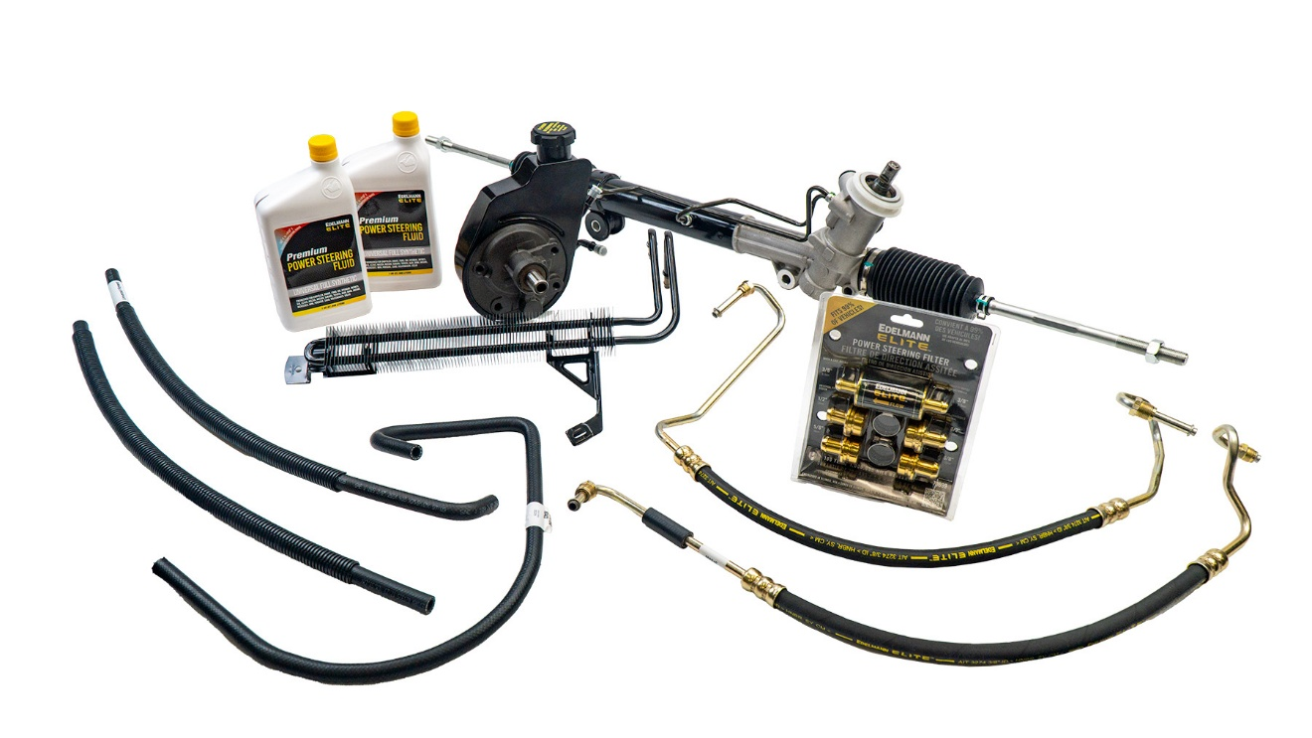

# # #

PR_11-04-25-1

