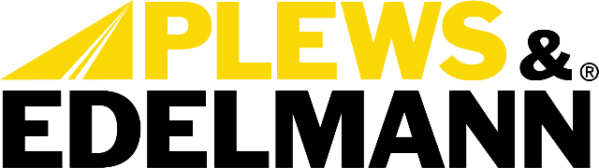

For Immediate Release:

Plews & Edelmann Bundles Target the Comeback, Not Just the Failed Part
• Every component the failure touched, ordered together under one bundle number
• 7,500+ bundles covering 100,000+ vehicle applications
• See the complete repair at AAPEX Forum Booth F13411, November 3-5
(Dixon, IL – November 2, 2026) — Plews & Edelmann® will bring its power steering bundles to AAPEX 2026, November 3-5 in Las Vegas, at AAPEX Forum Booth F13411, with a clear message for parts sellers and shops: the best warranty claim is the one that never gets filed. Each bundle puts the complete power steering repair, from pump to fluid, under a single bundle number, so the job is done once and done right.
A power steering failure is rarely one part. Debris from a failed pump can take a new rack down with it. A new rack installed on a tired hose is often back within months. Those comebacks cost everyone involved: the shop gives back the labor, the parts store takes back a part that was never the problem, and the vehicle owner loses another day and some trust in both. Plews & Edelmann builds its bundles to break that chain by replacing everything the failure touched, in one visit, with components matched to work together.
“Every counter has seen the same pump come back twice, and the pump was never the real problem,” said Tony Edwards, VP of Sales at Plews & Edelmann. “When a store sells the whole repair instead of one part, the shop gets a job that stays fixed, the customer gets their car back for good, and nobody spends the next month processing a return. That is the conversation we want to have with every distributor at AAPEX.”
Depending on the application, a bundle includes the pump, rack and pinion or gearbox, pressure hose(s), return hose(s), synthetic power steering fluid, a filter, and a cooler where the vehicle calls for one. Because Plews & Edelmann manufactures every one of those components, each bundle is built entirely from its own line rather than assembled from mixed sources.
Coverage is driven by Edelmann Analytics®, which maps each application down to details a typical catalog dropdown rarely asks about, including trim, chassis type, and whether a hydroboost brake system shares the pump. That depth is how 7,500+ bundles reach more than 100,000 vehicle applications, and it is what puts the right parts in the bundle for the vehicle on the lift.
“The difficult part of a complete repair isn’t knowing you need a hose and a filter. It’s knowing exactly which ones that specific vehicle takes,” said Anthony Holguin, Director of Category Management at Plews & Edelmann. “We do that work up front. A counter person looks up the vehicle in the catalog they already use, and the whole repair comes back under one number. No building the job line by line, no missed hose, no second trip.”

The bundle line also keeps growing. As Plews & Edelmann brings new parts to market, each one joins the bundles it belongs in, so every bundle remains the most complete power steering solution in the aftermarket. This approach is the core of the company’s Total Solution® philosophy: a lasting power steering repair addresses the entire system, not only the part that failed.
Bundles are available now through authorized aftermarket distributors and are live in the electronic catalogs your counterpeople already use. To learn more or find bundles for specific applications, visit www.plews-edelmann.com/bundles or call 1-800-770-4639.
About Plews & Edelmann
Plews & Edelmann® is a leading manufacturer and marketer of Edelmann® power steering hoses, electric power steering belt replacement kits, torque sensors, couplings and tools, power steering seal and rebuild kits, turbocharger oil lines, Edelmann Elite® high performance power steering hoses, all new manufactured power steering rack and pinion assemblies, pumps, gearboxes, remote reservoirs, power steering coolers, premium universal power steering filter and fluid.

Media Contact:
Sharon Clark
Marketing Coordinator
Plews & Edelmann
1550 Franklin Grove Road
Dixon, Illinois 61021
Phone: 815-220-5444
Email: sclark@plews.com
www.plews-edelmann.com

For the full Plews & Edelmann Press Kit: https://www.plews-edelmann.com/presskit

Image file: Edelmann_Power_Steering_Bundle.jpg
Caption: A complete Plews & Edelmann power steering bundle, pump to fluid
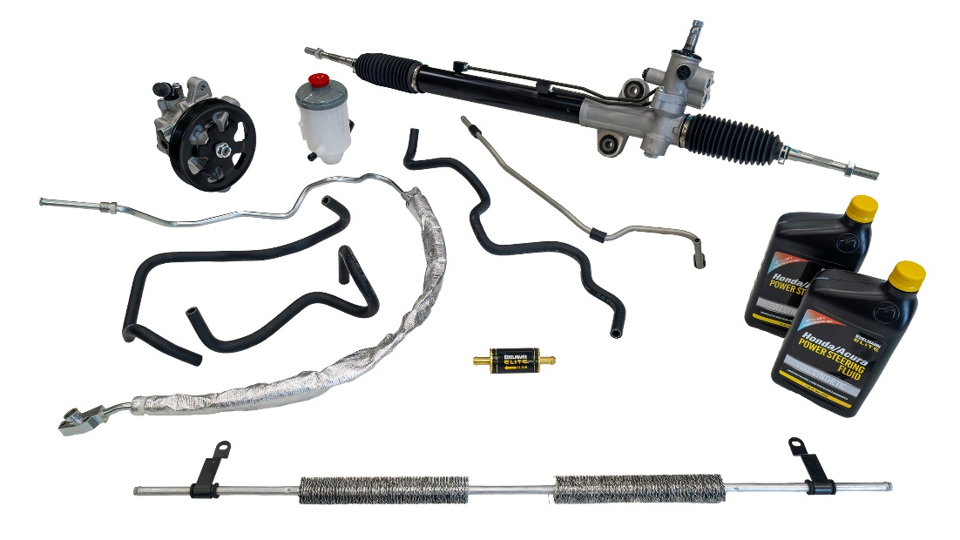

# # #

PR_11-02-26-1

