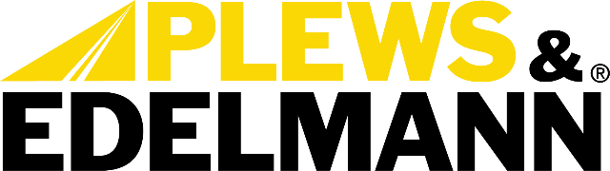

For Immediate Release:

Plews & Edelmann Introduces First Aftermarket Magnasteer Rack and Pinion Units
• Racks feature new coils engineered specifically for consistent performance
• Each unit features Edelmann Elite DNA for lifetime traceability
• Supplying the aftermarket with solutions to real world problems
(Dixon, Ill., October 31, 2023) — Plews, Inc., dba Plews & Edelmann of Dixon Illinois
Plews & Edelmann® a leading manufacturer of complete power steering solutions, today announced the launch of the first aftermarket manufactured replacement rack and pinion units featuring GM’s innovative Magnasteer technology. The new Edelmann Elite® racks cover select late model GM vehicles and provide technicians and auto repair facilities with a reliable and consistent replacement option not currently available.

Magnasteer combines traditional hydraulic power steering with electronically controlled magnetic forces to vary steering effort. GM first introduced Magnasteer in 1997 on Oldsmobile Aurora and Eighty Eight models before expanding it across brands. While improving steering feel and performance, the tight tolerances required for Magnasteer have made remanufacturing racks unreliable. With GM no longer supplying service units, no equivalent aftermarket option has existed until now.

A key reason that remanufactured Magnasteer racks tend to fail is that the magnetic coils are sealed inside the housing and cannot be serviced. Loss of coil function results in loss of power assist at low speeds. In contrast, the new Edelmann Elite racks feature completely new coils engineered specifically for consistent Magnasteer performance.

“Plews & Edelmann is committed to developing the power steering solutions that professional technicians truly need,” said Tony Edwards, Vice President of Sales & Marketing. “Magnasteer presented an obvious gap that we are now proud to fill with our engineering and manufacturing capabilities.”

Plews & Edelmann engineered a process and selected optimal materials to hold the extremely tight tolerances demanded by Magnasteer technology. Extensive testing validated the company’s ability to repeatedly produce new racks meeting required performance standards. Each unit also features the Edelmann Elite unique Designated Numeric Asset™ (DNA) for lifetime traceability and performance confidence.

The new Magnasteer program expands the existing Edelmann Elite line of manufactured rack and pinion units by an additional 1.6 million domestic and import vehicles. Combined with the company’s complete portfolio of power steering hoses, pumps, coolers and filter, Plews & Edelmann offers auto repair shops a single source for every power steering repair scenario.

“Professional technicians told us they needed a consistent Magnasteer option, and that’s exactly what we developed,” said Edwards. “We go the extra mile at Plews & Edelmann to supply the aftermarket with solutions to real world problems.”

For more information, visit www.plews-edelmann.com.

About Plews & Edelmann
Plews & Edelmann® is a leading manufacturer and marketer of Edelmann® power steering hoses, repair kits, turbocharger oil lines, Edelmann Elite® high performance power steering hoses, NEW manufactured power steering rack and pinion assemblies, pumps, gear boxes, power steering coolers, premium universal power steering filter and fluid.

Media Contact:
Sharon Clark
Marketing Coordinator
Plews & Edelmann
1550 Franklin Grove Road
Dixon, Illinois 61021
Phone: 815-220-5444
Email: sclark@plews.com
www.plews-edelmann.com

# # #

Image file: Magnasteer Rack.jpg
Caption: Aftermarket Magnasteer Rack and Pinion Units

PR_10-31-23-2

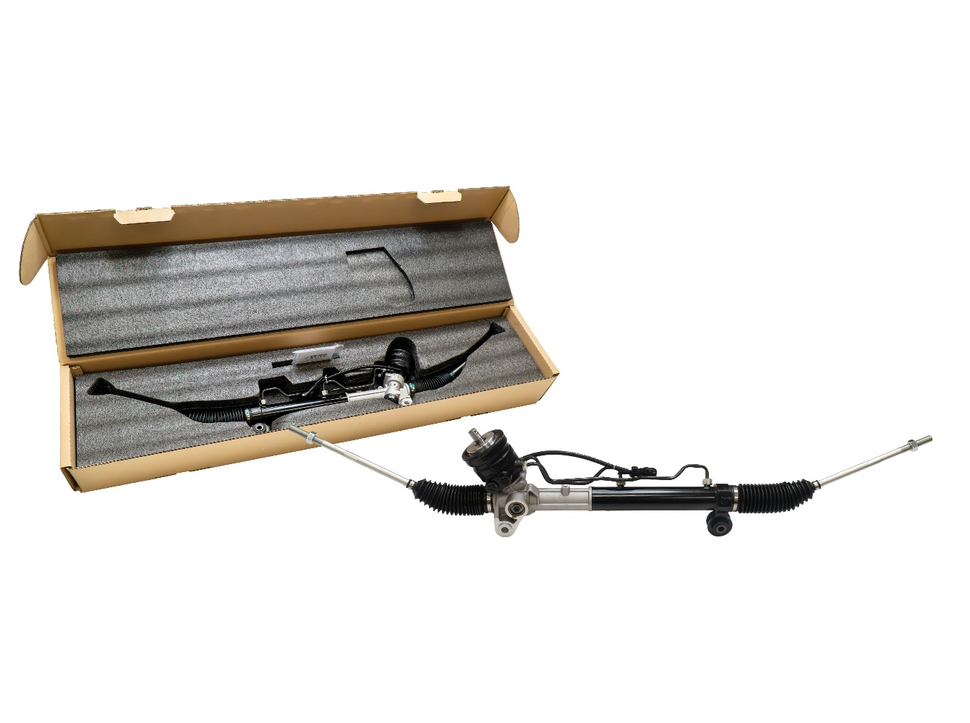

For the full Plews & Edelmann Press Kit: https://www.plews-edelmann.com/presskit

