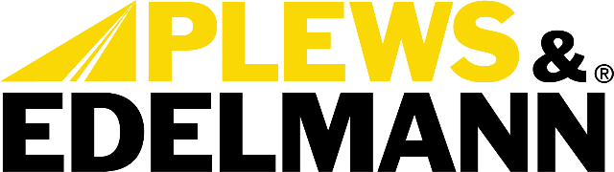

For Immediate Release:

Plews & Edelmann Addresses Critical Supply Chain Gaps with Exclusive NEW Manufactured Steering Components

• NEW Nissan Titan rack addresses critical supply shortage in commercial truck segment
• Exclusive manufacturing fills documented market demand unmet by remanufacturers
• Significant cost savings for retailers and end customers compared to scarce reman alternatives

(Dixon, IL - November 4, 2025) — Plews & Edelmann® is showcasing its expanding portfolio of exclusive newly manufactured power steering components at AAPEX 2025, highlighting solutions that address critical gaps in aftermarket parts availability. Featured prominently is the company's NEW rack and pinion assembly for 2017-2024 Nissan Titan applications, which demonstrates strong market demand despite serving a relatively modest 155,000 VIO application.

The robust performance of the Titan rack illustrates a broader supply chain challenge facing the aftermarket: insufficient core availability for remanufacturing is creating scarcity and inflated pricing for certain high-demand applications. The Edelmann Elite® newly manufactured option offers significant cost savings while providing enhanced durability through a bolstered rack shaft designed specifically for heavy-duty and towing applications.

"Our research identified numerous high-demand applications where customers are actively searching for parts that simply aren't available through traditional remanufacturing channels," said Anthony Holguin, Director of Category Management at Plews & Edelmann. "By investing in NEW manufacturing capabilities for these specific applications, we're enabling our distribution partners to capture sales opportunities they're currently missing while providing end customers with more reliable solutions at lower cost."

The Titan rack represents the company’s strategic approach to filling documented market gaps with exclusive newly manufactured components. The company has developed similar solutions for other applications experiencing supply constraints, including power steering components for the Dodge Charger (1 million VIO), Honda Ridgeline (160,000 VIO), and Ford Transit commercial vehicles (1.5+ million combined VIO).

These exclusive offerings provide retailers with competitive advantages in increasingly challenging market conditions. Newly manufactured parts eliminate reliability concerns associated with remanufactured components while offering significant cost savings to end customers. The exclusivity of the Plews & Edelmann manufacturing approach creates differentiation for distribution partners in markets where traditional suppliers cannot provide consistent availability.

"The aftermarket faces increasing pressure to provide comprehensive coverage while managing inventory efficiently," added Holguin. "Our exclusive newly manufactured parts allow distribution partners to enhance their coverage with minimal inventory investment while capturing sales that are currently going unfulfilled."

Plews & Edelmann will demonstrate its complete line of power steering components at AAPEX Booth A3629. The showcase will feature the company's rack and pinion assemblies, pumps, and gear boxes, hoses, coolers, filter, and fluid, along with its revolutionary electric power steering repair solutions.

The exclusive parts portfolio is part of the company’s year-long "Missed Opportunities" campaign, which identifies high-demand applications where documented customer searches exceed available supply through traditional distribution channels.

For more information about Plews & Edelmann exclusive steering components, visit www.plews-edelmann.com or call 1-800-770-4639.
About Plews & Edelmann
Plews & Edelmann® is a leading manufacturer and marketer of Edelmann® power steering hoses, electric power steering belt replacement kits, couplings and tools, power steering seal and rebuild kits, turbocharger oil lines, Edelmann Elite® high performance power steering hoses, all new manufactured power steering rack and pinion assemblies, pumps, gear boxes, power steering coolers, premium universal power steering filter and fluid.

Media Contact:
Sharon Clark
Marketing Coordinator
Plews & Edelmann
1550 Franklin Grove Road
Dixon, Illinois 61021
Phone: 815-220-5444
Email: sclark@plews.com
www.plews-edelmann.com

Image file: Titan Power Steering Rack 2163.jpg
Caption: Edelmann Elite NEW Nissan Titan Rack and Pinion Assembly

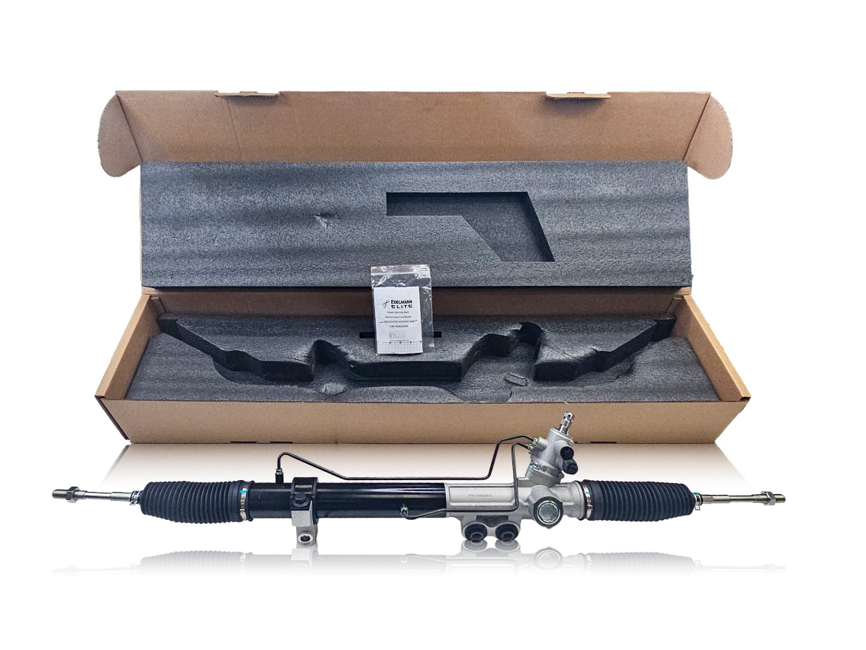

# # #

PR_11-04-25-2

