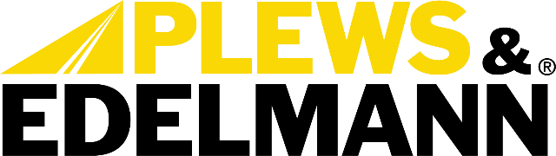

For Immediate Release:

Revolutionary New Steering Repair Option Eliminates Need for Full Rack Replacement
• Replacement kits offer cost-effective repair solution
• Provides critical service option when replacement racks are scarce
• Kits contain all components necessary to complete the service.
(Dixon, Ill., October 31, 2023) — Plews, Inc., dba Plews & Edelmann of Dixon Illinois
Plews & Edelmann® has introduced an innovative new repair solution set to revolutionize electric power steering servicing. The Edelmann® Electric Steering Rack and Pinion Drive Belt Replacement Kit fills a void where previously no service options existed outside of full rack replacement. Now, technicians and DIYers have a cost-effective, mechanical fix for worn or failed EPS drive belts.

The complete replacement cost of modern electric racks has left drivers facing steep repair bills, made worse by low availability of replacement parts in some circumstances. The Edelmann belt kit is the first solution to offer easy, affordable repairs without needing to source a new rack.

Each kit contains a new belt manufactured to OE specifications along with all necessary components to complete the service. OE fit, form and function is ensured across seals, clamps and parts. With parts included for a complete fix, technicians can avoid relying on hard-to-find parts that may be unavailable. The repair can be performed with commonly available tools, and no reprogramming is necessary with this type of repair.

"By introducing the EPS belt repair option, we've filled a huge void in serviceability for these systems," said Evan Bauer, Director of Category Management at Plews & Edelmann. "Our kit empowers repairs that simply weren't possible before. And it provides a critical service option when replacement racks are scarce."

"We're excited to introduce this first-of-its-kind solution to an extremely common issue facing vehicles today," said Anthony Holguin, Category Manager at Plews & Edelmann. "These kits provide opportunity and convenience by enabling quick, affordable repairs using basic tools. It's a game changer for servicing modern electric steering systems."

The Edelmann Electric Steering Rack and Pinion Drive Belt Replacement Kits cover a wide range of late model domestic and import applications. Detailed video instructions accessible by QR code provide step-by-step guidance to make the fix even simpler. As with all Plews & Edelmann products, the kits are backed by over 70 years of steering system expertise.

The full line is available now for distribution across North America. To learn more or find kits for specific vehicle applications, visit www.plews-edelmann.com/eps.

About Plews & Edelmann
Plews & Edelmann® is a leading manufacturer and marketer of Edelmann® power steering hoses, repair kits, turbocharger oil lines, Edelmann Elite® high performance power steering hoses, NEW manufactured power steering rack and pinion assemblies, pumps, gear boxes, power steering coolers, premium universal power steering filter and fluid.

Media Contact:
Sharon Clark
Marketing Coordinator
Plews & Edelmann
1550 Franklin Grove Road
Dixon, Illinois 61021
Phone: 815-220-5444
Email: sclark@plews.com
www.plews-edelmann.com

# # #

Image file: Edelmann EPS Kits.jpg
Caption: Replacement Kits Offer Cost-Effective Repair Solution

PR_10-31-23-1

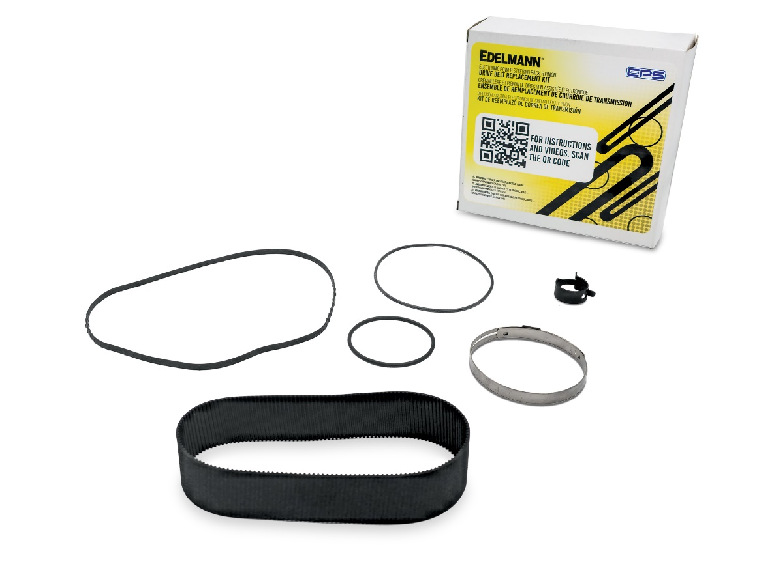

For the full Plews & Edelmann Press Kit: https://www.plews-edelmann.com/presskit

