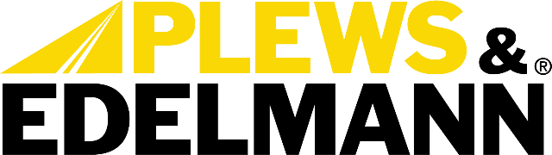

For Immediate Release:

Edelmann Elite Universal Coolers Bring OE-Quality, Improved Performance and Easy Installation to the Aftermarket
• Coolers are equipped with internal turbulators
• E-coated exterior for enhanced protection in harsh underhood conditions
• Each kit comes complete with hoses, clamps and mounting hardware
(Dixon, Ill., October 31, 2023) — Plews, Inc., dba Plews & Edelmann of Dixon Illinois
Plews & Edelmann®, a leading manufacturer of OE-quality power steering solutions, has introduced the new Edelmann Elite® Universal Coolers to bring improved cooling performance and hassle-free installation to vehicles lacking factory power steering coolers.

The expertly engineered Edelmann Elite Universal Coolers are equipped with internal turbulators that churn fluid for superior heat dissipation, outperforming similarly sized aftermarket options. The single-tube design prevents leaks and uneven flow while the exclusive direct-fit universal mounting brackets allow for quick and secure installation on nearly any vehicle.

"We saw a need in the aftermarket for a high-quality universal power steering cooling solution," said Evan Bauer, Director of Category Management at Plews & Edelmann. "Our new Edelmann Elite Universal Coolers offer confidence to installers and vehicle owners by combining top-notch engineering and durability with simplified installation."

While inferior aftermarket coolers often fail prematurely from corrosion, the Edelmann Elite Universal Coolers feature an E-coated exterior for enhanced protection and longevity in harsh underhood conditions. Each kit comes complete with all required hoses, clamps, and hardware for hassle-free installation right out of the box.

Dual size options are available - a compact model for tight engine bays needing maximum cooling in minimal space, and a larger high-capacity cooler for demanding applications like towing and fleet vehicles.

Bauer added, " Bauer said, "Whether a vehicle lacks a factory cooler, or the OEM cooler doesn't cut it, our new Edelmann Elite coolers outperform other aftermarket choices. Customers can feel assured their system is protected, even under extreme conditions."

The Edelmann Elite Universal Coolers are the latest addition to Plews & Edelmann's line of OE-quality power steering solutions, including hoses, racks, pumps, gearboxes, filters, and fluid. The new universal coolers exemplify their commitment to delivering the TOTAL SOLUTION® for power steering to the automotive aftermarket.

The Edelmann Elite Universal Coolers are available now through Plews & Edelmann distributors nationwide. To learn more, visit www.plews-edelmann.com/coolers.

About Plews & Edelmann
Plews & Edelmann® is a leading manufacturer and marketer of Edelmann® power steering hoses, repair kits, turbocharger oil lines, Edelmann Elite® high performance power steering hoses, NEW manufactured power steering rack and pinion assemblies, pumps, gear boxes, power steering coolers, premium universal power steering filter and fluid.

Media Contact:
Sharon Clark
Marketing Coordinator
Plews & Edelmann
1550 Franklin Grove Road
Dixon, Illinois 61021
Phone: 815-220-5444
Email: sclark@plews.com
www.plews-edelmann.com

# # #

Image file: Universal Coolers.jpg
Caption: Dual size options are available – compact for tight spaces and heavy-duty for towing
PR_10-31-23-3

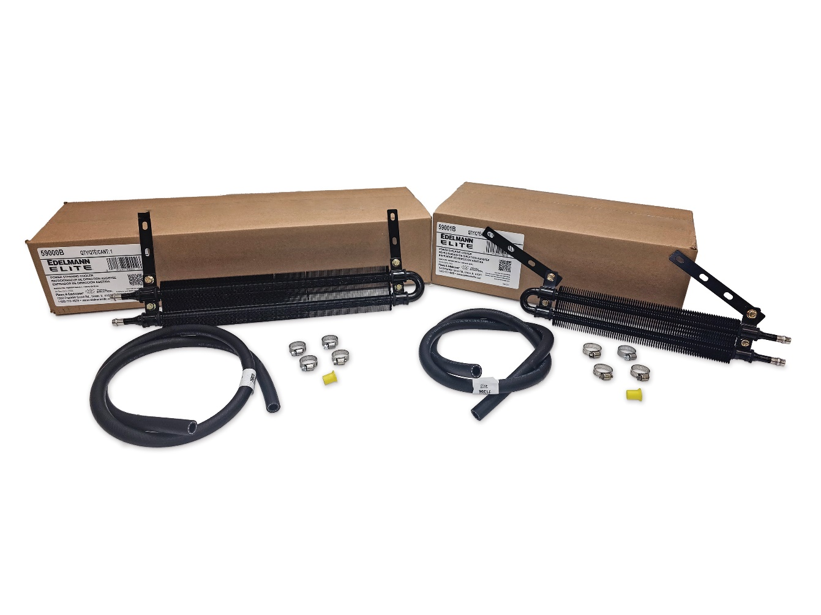

For the full Plews & Edelmann Press Kit: https://www.plews-edelmann.com/presskit

