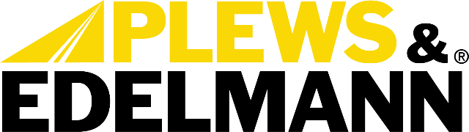

For Immediate Release:

Plews & Edelmann Launches New Company Overview Catalog Highlighting Total Solution for the Power Steering Aftermarket

• Provides a comprehensive look at the Total Solution for the Power Steering
Aftermarket
(Dixon, Ill., October 31, 2023) — Plews, Inc., dba Plews & Edelmann of Dixon Illinois
Plews & Edelmann, a leading manufacturer of power steering solutions, announced today the release of its new Company Overview catalog. This 28-page catalog provides a comprehensive look at Plews & Edelmann's Total Solution® offering for the power steering aftermarket.

"We are thrilled to introduce our new company overview, which fully captures our identity as the premier Total Solution provider for power steering repairs," said Andrew Moe, Director of Marketing Services. "This material clearly outlines the unparalleled value we bring through our innovative Edelmann® and Edelmann Elite® product lines, proprietary Edelmann Analytics® program, and best-in-class North American supply chain."

The overview highlights Plews & Edelmann's unique position as the only company to offer everything needed for a complete power steering system repair. This includes new manufactured hard parts, high performance hoses, OE equivalent coolers, premium synthetic fluid, and a universal power steering filter.

It also outlines the key benefits of the industry-leading 100 year/1 million mile warranty on Edelmann Elite® parts and details how the company's commitment to North American sourcing ensures responsiveness and availability.

Additionally, the overview explains how Edelmann Analytics®, a Plews & Edelmann proprietary software provides customized intelligence to help customers optimize inventory, forecasting, and sales.

"With this new company overview, we present the clearest picture yet of how our Total Solution approach brings game-changing advantages to power steering repairs," said Moe. "We look forward to getting this valuable sales tool into the hands of distributors, retailers, and service technicians nationwide."

The 28-page, full color catalog is available in print and digital formats. To request a catalog or download a PDF, visit www.plews-edelmann.com or call 800-770-4639.

About Plews & Edelmann
Plews & Edelmann® is a leading manufacturer and marketer of Edelmann® power steering hoses, repair kits, turbocharger oil lines, Edelmann Elite® high performance power steering hoses, NEW manufactured power steering rack and pinion assemblies, pumps, gear boxes, power steering coolers, premium universal power steering filter and fluid.

Media Contact:
Sharon Clark
Marketing Coordinator
Plews & Edelmann
1550 Franklin Grove Road
Dixon, Illinois 61021
Phone: 815-220-5444
Email: sclark@plews.com
www.plews-edelmann.com

# # #

Image file: Corporate Overview.jpg
Caption: Total Solution Catalog for the Power Steering Aftermarket

PR_10-31-23-4

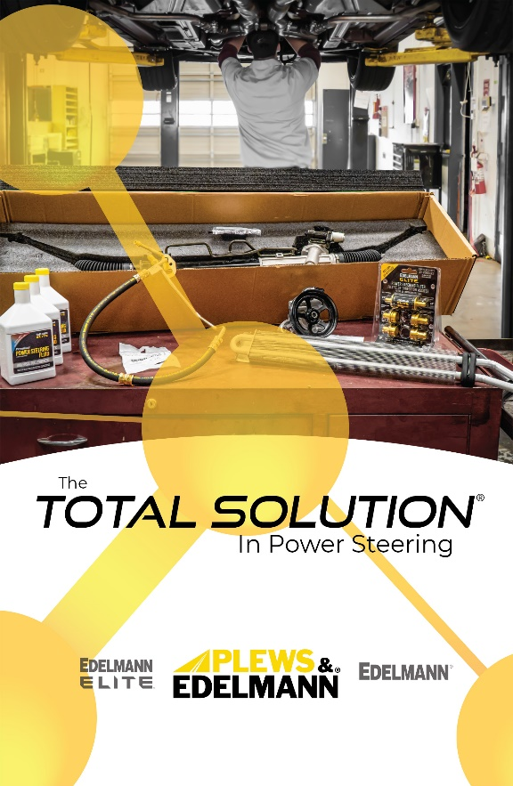

For the full Plews & Edelmann Press Kit: https://www.plews-edelmann.com/presskit

