

For Immediate Release:

Find the Real EPS Failure Before Replacing the Rack
• Torque sensors join belt kits, couplings, and tools for targeted EPS repair
• Expanding line of brand-new non-programmable racks: no programming,
no core charge
• See the complete EPS lineup at AAPEX Forum Booth F13411, November 3-5
(Dixon, IL – November 2, 2026) — Plews & Edelmann® will bring its full Electric Power Steering (EPS) repair lineup to AAPEX, built around one idea: find the part that actually failed before replacing the rack. This year the company added Edelmann® Torque Sensors to its EPS line and continued to expand its range of brand-new Edelmann® and Edelmann Elite® non-programmable racks, giving shops a right-sized fix for each kind of EPS failure.
EPS is now standard on most new vehicles, and as those vehicles age out of warranty, they are arriving in independent bays in growing numbers. Too often, the first answer to an EPS complaint is a new rack or column module. These replacements can cost over $1,000 in parts alone, and when these components aren’t the real failure, the problem returns. The shop ends up doing the job twice or concedes and sends the customer to the dealer for a repair it could have handled for less.
The Plews & Edelmann answer is a diagnose-first approach. A lot of EPS work is targeted: a worn drive belt, a failed coupling, or a faulty torque sensor. Edelmann EPS Drive Belt Kits (9600 to 9611), Couplings (9700, 9701, and 9702), and new Torque Sensors (9704 and 9705) let technicians fix the failed component with the original motor and module left in place, so there is no module re-flash and no realignment, for more than 50% less than a full replacement.
“Shops don’t lose money on EPS because the work is hard. They lose it when the wrong part goes on and the problem isn’t fixed,” said Anthony Holguin, Director of Category Management at Plews & Edelmann. “A failed torque sensor and a failed rack can look the same from the driver’s seat. Our job is to give the technician the diagnostic support to tell them apart and the exact part to fix what they find, so the first repair is the last one.”
Edelmann Torque Sensors, introduced earlier this year, address one of the most common sources of EPS complaints. The torque sensor measures how hard and in which direction the driver turns the wheel and reports it to the EPS control module. When it fails, drivers notice uneven steering effort, an intermittent EPS warning light, or a complete loss of assist, symptoms that often lead to an unnecessary rack replacement. Parts 9704 and 9705 are direct OE-replacement designs with mounting hardware and alignment marks. Replacing the sensor instead of the rack keeps a job in the independent shop that previously went to the dealer.
When the rack itself is the failure, from a curb impact, internal wear, or a bent shaft, the Plews & Edelmann expanding line of non-programmable racks provides the fix. On column-assist EPS systems, the motor and torque sensor are mounted on the steering column and the rack itself is mechanical. These racks are 100% new construction, not remanufactured, require no programming, and carry no core charge. The line currently includes 50 SKUs covering 38 million U.S. vehicles.
“The EPS aftermarket is growing every year, and the shops that win it will be the ones that repair the system instead of swapping parts,” said Tony Edwards, VP of Sales at Plews & Edelmann. “We want every counter person and every technician to know they have an option instead of the dealer. That means a sensor when it’s the sensor, a belt kit when it’s the belt, and a brand-new rack only when the rack is truly beyond repair.”
Many Edelmann EPS repair options are backed by vehicle-specific installation videos, diagnostic videos, tech tips, and ASE Certified Technical Support. It is the Plews & Edelmann Total Solution® for EPS: fix what failed and install it new only when that is the right call.
AAPEX attendees can see the complete EPS lineup at AAPEX Forum Booth F13411. Edelmann Torque Sensors, EPS Drive Belt Kits, Couplings, Chamfer Ring Tools, and non-programmable racks are available now through authorized aftermarket distributors. To learn more or find EPS parts for specific applications, visit www.plews-edelmann.com/eps or call 1-800-770-4639.
About Plews & Edelmann
Plews & Edelmann® is a leading manufacturer and marketer of Edelmann® power steering hoses, electric power steering belt replacement kits, torque sensors, couplings and tools, power steering seal and rebuild kits, turbocharger oil lines, Edelmann Elite® high performance power steering hoses, all new manufactured power steering rack and pinion assemblies, pumps, gearboxes, remote reservoirs, power steering coolers, premium universal power steering filter and fluid.
Media Contact:
Sharon Clark
Marketing Coordinator
Plews & Edelmann
1550 Franklin Grove Road
Dixon, Illinois 61021
Phone: 815-220-5444
Email: sclark@plews.com
www.plews-edelmann.com

For the full Plews & Edelmann Press Kit: https://www.plews-edelmann.com/presskit

Image file: Edelmann_EPS_Repair_Lineup.jpg
Caption: Edelmann torque sensors, belt kits, couplings, and non-programmable racks
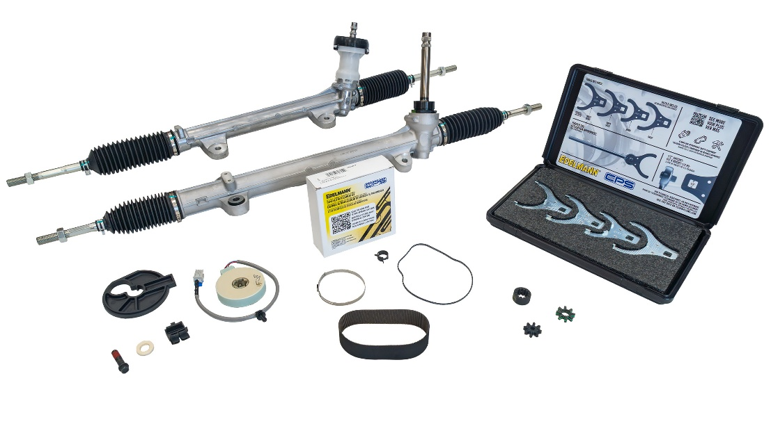

# # #

PR_11-02-26-2

