

For Immediate Release:

When No One Else Builds the Part New, an Empty Shelf Loses the Sale
• 82 power steering parts manufactured new by Plews & Edelmann alone
• Applications covering more than 31 million vehicles in operation
• Discuss exclusives with the team at AAPEX Forum Booth F13411, November 3-5
(Dixon, IL – November 2, 2026) — Heading into AAPEX 2026, Plews & Edelmann® has a direct message for distributors: 82 of its power steering parts are manufactured NEW by no other supplier, and every store that does not stock them is turning away sales it could easily keep. The exclusive line of rack and pinion assemblies, pumps, gearboxes, and power steering coolers covers applications on more than 31 million vehicles in operation, and the Plews & Edelmann team will be at AAPEX Forum Booth F13411 to talk with distributors about which of those parts are missing from their shelves.
The opportunity starts with a simple moment at the counter. A customer wants a new power steering part for their vehicle. The counter person searches the catalog and finds nothing. Because no one else builds that part new, there is no competing brand to offer in its place. The customer leaves, and the sale goes to whichever store has it on the shelf. Multiplied across millions of vehicles, those empty searches add up to real revenue walking out the door, every day, at stores that never knew they were losing it.
These parts exist because Plews & Edelmann goes after the applications others leave behind but are still in high demand. Many of them fit high-volume vehicles where the original equipment has worn out and few quality replacements remain, including the 1997-2003 Ford F-150, the 2010-2017 Chevrolet Equinox and GMC Terrain, and the 2007-2021 Toyota Tundra. Each part is newly manufactured to or better than OE-quality standards, so the technician gets the same fit, form, and improved function of the original equipment.
“Our exclusives are some of the easiest sales a distributor will ever make, because the customer has already decided what they need and there is nowhere else to get it new,” said Tony Edwards, VP of Sales at Plews & Edelmann. “The only thing standing between that customer and a sale is whether the part is in the system. We want every distributor who visits us at AAPEX to leave knowing exactly which of these parts they are missing.”
The exclusive line breaks down into 49 rack and pinion assemblies, 22 power steering coolers, six pumps, and five gearboxes. Rack and pinion assemblies alone cover more than 17 million vehicles in operation, and coolers more than 9 million. Because each part covers an application with no new alternative, adding it gives a distributor coverage its competitors cannot match without coming to Plews & Edelmann as well.
“Building a part no one else will build is a commitment, and we make it because those vehicles still need to be fixed,” said Dan Billie, CEO of Plews & Edelmann. “When a shop can get a brand-new part instead of telling a customer the vehicle can’t be repaired, everyone in that chain wins. Our job is to make that part. Our distributors’ job is to make sure the customer can find it.”
AAPEX attendees can talk with the Plews & Edelmann team about exclusive parts at AAPEX Forum Booth F13411. All 82 parts are available now. The complete, searchable list, with fitments and vehicles in operation for each part, is at https://exclusives.plews-edelmann.com. To add exclusive parts to inventory, email orders@plews.com, visit www.plews-edelmann.com, or call 1-800-770-4639.
About Plews & Edelmann
Plews & Edelmann® is a leading manufacturer and marketer of Edelmann® power steering hoses, electric power steering belt replacement kits, torque sensors, couplings and tools, power steering seal and rebuild kits, turbocharger oil lines, Edelmann Elite® high performance power steering hoses, all new manufactured power steering rack and pinion assemblies, pumps, gearboxes, remote reservoirs, power steering coolers, premium universal power steering filter and fluid.
Media Contact:
Sharon Clark
Marketing Coordinator
Plews & Edelmann
1550 Franklin Grove Road
Dixon, Illinois 61021
Phone: 815-220-5444
Email: sclark@plews.com
www.plews-edelmann.com
For the full Plews & Edelmann Press Kit: https://www.plews-edelmann.com/presskit

Image file: Edelmann_Exclusive_Parts.jpg
Caption: Exclusive Plews & Edelmann racks, coolers, pumps, and gearboxes

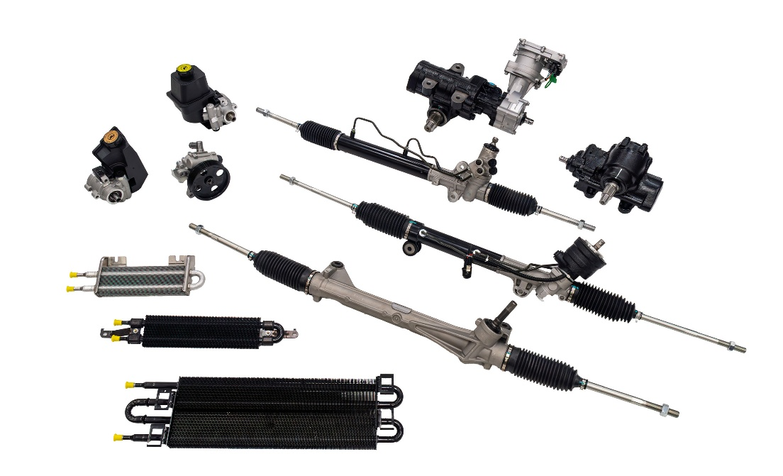

# # #

PR_11-02-26-3

